Description of the database

This is the description of the English database, the Arabic database will be an exact copy with a different connection string. The connection string will change as the language is changed.

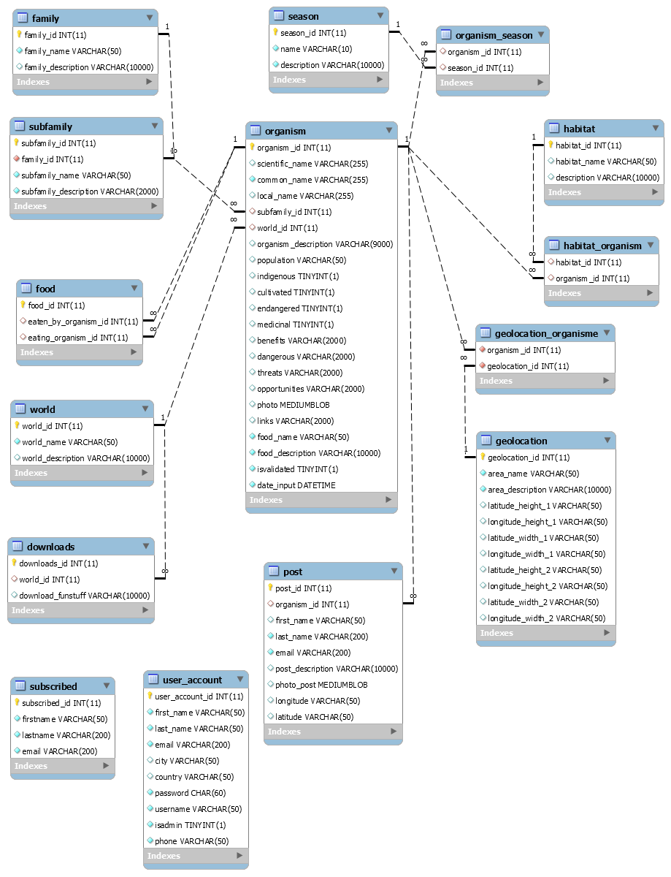

Relations ordered by links

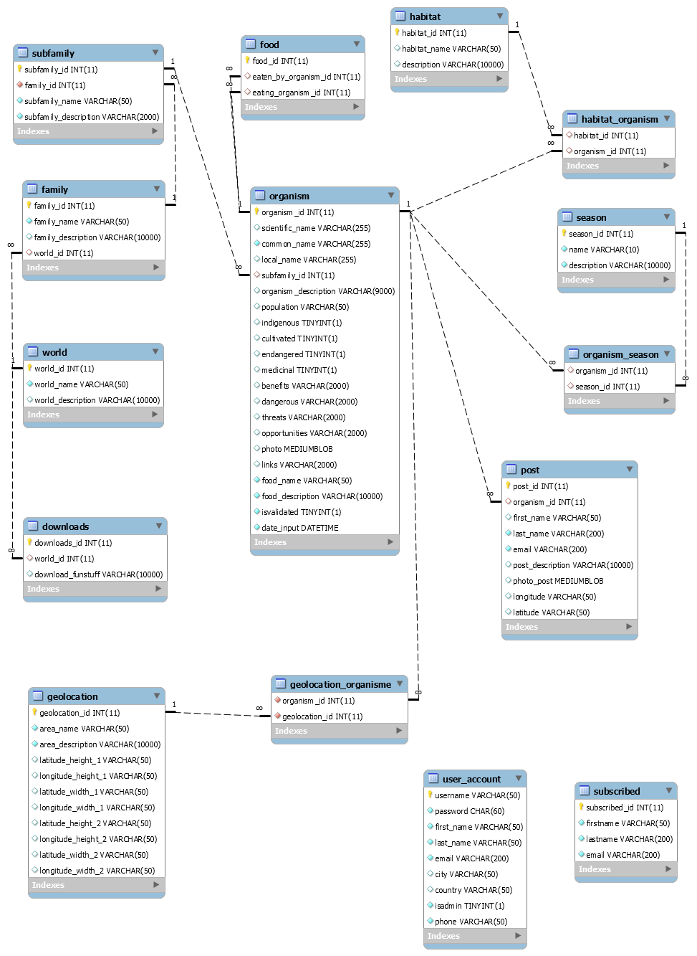

|  |  |
| --- | --- |
|  | * Primary key * Latin name * Most used name * Local name can be different than the common name * Subfamily inherits from family to create a many-to-one relation * World is one part of the exhibition * Season from subtable organism_season to create a many-to-many relation * Description * Population hardcoded as varchar (e.g. <1200 animals alive) * Indigenous to Oman or not * Cultivated in agriculture * Endangered Boolean * Medicinal Boolean * Benefits: description of possible benefits * Dangerous: description of possible dangers * Threats: what threatens a certain organism * Opportunities: future possible use of an organism * Photo max 15MB * Links to external webpages (e.g. Wikipedia) * QR code that is added to each exhibition piece * Food of an organism that is not in de database * Description of the not-stored food |

|  |  |
| --- | --- |
|  | * Primary key * Eaten_by_organism: the organism that gets eaten. * Eating_ organism: eats the Eaten_by_organism. |

|  |  |
| --- | --- |
|  | * Habitat is grassland, desert, mountains, ocean, shallow ocean. This order should be respected in the Arabic version to uphold consistency. * The relation is made to get 1 to create a many-to-one relation. * An organism can live in more than 1 habitat. |

|  |  |
| --- | --- |
|  | * Season spring, summer, fall, winter. The table is created to easily insert the Arabic version. * The relation is made to get 1 to create a many to one relation * An organism can live or be harvested in more than 1 season. |

|  |  |
| --- | --- |
|  | * Family: e.g. mammals, reptiles, birds, etc. * Subfamily: e.g. camels would belong to mammals, pelicans would belong to birds, etc. * An organism can only have 1 family but a family can have more than 1 subfamily |

|  |  |
| --- | --- |
|  | * World parts of the exhibition;   The marine world  The plant world  The animal world  The microbial world   * The table is created to easily insert the Arabic version. |

|  |  |
| --- | --- |
|  | * Post table keeps records sent to the administrator of a spotting of an organism with optional comment. These are collected in order to send a newsletter and create an interactive map of the spottings. * Longitude to make the interactive map * Latitude to make the interactive map * News_letter Boolean: wants to receive or not |

|  |  |
| --- | --- |
|  | * Geolocation table keeps record to make the interactive map to show where an animal lives * Foreign key to 1 organism * Area name * Area description of this area * More points to make the area |

|  |  |
| --- | --- |
|  | * Admin can perform CRUD action on the database, basic records are stored. * Login is required therefore password, username. |

|  |  |
| --- | --- |
|  | * Downloads to games, colorings, etc. per world * Foreign key to worlds * Download_funstuff are the links separated by a “,” |